(OS Project Report)

Topic : Multilevel Queue Scheduling



Submitted to : NEHA SHARMA

Prepared By: Nitin Rathore
Registration No: 11702588
Section: K17DW
Roll Number: B40
Subject Code: CSE316

GitHub Id : Nitin994644
Link : https://github.com/Nitin994644/OS-Project
Explanation :

Multilevel Queue Scheduling is used where It may happen that processes in the ready queue can be divided into different classes where each class has its own scheduling needs. For example, a common division is an interactive process and batch processes. These two classes have different scheduling needs.

Ready Queue is divided into separate queues for each class of processes. In addition, there must be scheduling among the queues, which is commonly implemented as fixed-priority pre-emptive scheduling.

For example:

The Interactive process queue may have absolute priority over the batch process queue. Each queue has absolute priority over lower-priority queues.
No process in the batch queue, for example, could run unless the queues for system processes, interactive processes, and interactive editing processes were all empty.

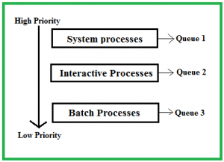

Question :

Write a program for multilevel queue scheduling algorithm. There must be three queues generated. There must be specific range of priority associated with every queue. Now prompt the user to enter number of processes along with their priority and burst time. Each process must occupy the respective queue with specific priority range according to its priority.

Apply Round Robin algorithm with quantum time 4 on queue with highest priority range. Apply priority scheduling algorithm on the queue with medium range of priority and First come first serve algorithm on the queue with lowest range of priority. Each and every queue should get a quantum time of 10 seconds. CPU will keep on shifting between queues after every 10 seconds
Program Brief :
Queues:

- Round Robin of Time Quantum – 4
- Priority Scheduling Algorithm
- FCFS (First Come First Serve)

1. Starting from the Main() , The function process_detail() is used to take the input from the user regarding the process. The input consists of the Priority on the basis of which the processes are sent into the queues.

2. The Priority for the first Queue ranges from 1 to 5 (Round Robin of TQ = 4) , for the second queue it ranges from 6 to 10 (Priority Queue) and for the third queue it ranges from 11 to 15 (FCFS Queue).

3. The Other input consists of the Arrival and Burst time of the process which are stored in a class data type Process. It also consists of a variable p_a which is used to access the inputs of each process required during processing.

4. After storing the information in the class the data is traversed using the function queue_entry() and is checked for the arrival time of each process and depending on the arrival time they are sent into the queues { RR,PR and FCFS }.

5. After the processes are assigned into the queues while loop is used to schedule all the queue with respect to Round Robin of TQ = 10.

6. The while loop consists of three while loops each comprising of one of the algorithm. First while loop consists of RR of TQ = 4 , second consists of Priority Algorithm and third consists of FCFS (First Come First Serve).

7. In each while loop when the time quantum of Round Robin (10) is completed the burst time of the currently running process is updated and is stored in its burst time variable and other condition which is when burst completes the queue is checked if it has any other process to get processed and then it is loaded into the processing.

8. Whenever the process is completed it is printed on the screen with its time of completion and for each second of processing is printed along with running time.

9. At the end of all the while loops the check1() function is used which checks if all the queues if they are empty and if they are empty the condition of main while loop is made false and scheduling is completed.

10. The check2() function is used to check if there exist a process or not at every time of processing (i.e.) if it doesn’t find any process currently it traverses through the structure if there is any process yet to arrive and when there is no process at a particular second then no process has arrived at this time is printed.
Program Code :
#include<unistd.h>
#include<stdio.h>
int q1c,q2c,q3c;
int roundrobin(int a, int b);
int fcfs(int a, int b);
int priority(int a , int b);
int waiting_time[20];
int main()
{
//int q1c,q2c,q3c;
printf("\n\t\tEnter number of processes in queue 1\t\t::\t\t");
scanf("%d",&q1c);
printf("\n\t\tEnter number of processes in queue 2\t\t::\t\t");
scanf("%d",&q2c);
printf("\n\t\tEnter number of processes in queue 3\t\t::\t\t");
scanf("%d",&q3c);
int p1,p2,p3;

char name[3];
printf("\n\t\tEnter priority of queue 1\t\t::\t\t");
scanf("%d",&p1);
while(1)
{
printf("\n\t\tEnter priority of queue 2\t\t::\t\t");
scanf("%d",&p2);
if(p1!=p2)
{
break;
}
else
{
printf("priorities cannot be equal");
}
}
while(1)
{
printf("\n\t\tEnter priority of queue 3\t\t::\t\t");
scanf("%d",&p3);
if(p1!=p3&&p2!=p3)
{
break;
}
else
{
printf("priorities cannot be equal");
}
}
if (p1<p2&&p1<p3)
{
roundrobin(q1c,1);
if(p2<p3)
{
priority(q2c,2);
fcfs(q3c,3);
}
else
{
priority(q3c,3);
fcfs(q2c,2);
}
}
else if(p2<p1&&p2<p3)
{
roundrobin(q2c,2);
if(p1<p3)
{
priority(q1c,1);
fcfs(q3c,3);
}
else
{
priority(q3c,3);
fcfs(q1c,1);
}
}
else
{
roundrobin(q3c,3);
if(p1<p2)
{
priority(q1c,1);
fcfs(q2c,2);
}
else
{
priority(q2c,2);
fcfs(q1c,1);
}
}
}

int priority(int a,int b)
{
int burst_time[20], process[20], turnaround_time[20], priority[20];
int i, j, limit, sum = 0, position, temp;
float average_wait_time, average_turnaround_time;
printf("\n Applying priority scheduling algorithm on queue no. %d",b);
/*printf("Enter Total Number of Processes:\t");
scanf("%d", &limit);*/
limit=a;
int ask=1;
printf("\n Enter Burst Time and Priority For %d Processes\n", limit);
if(ask=1)
{
for(i = 0; i < limit; i++)
{
printf("\nProcess[%d]\n", i + 1);
printf("Process Burst Time:\t");
scanf("%d", &burst_time[i]);
printf("Process Priority:\t");
scanf("%d", &priority[i]);
process[i] = i + 1;
}
ask=0;
}
for(i = 0; i < limit; i++)
{
position = i;
for(j = i + 1; j < limit; j++)
{
if(priority[j] < priority[position])
{
position = j;
}
}
temp = priority[i];
priority[i] = priority[position];
priority[position] = temp;
temp = burst_time[i];
burst_time[i] = burst_time[position];
burst_time[position] = temp;
temp = process[i];
process[i] = process[position];
process[position] = temp;
}
waiting_time[0] = 0;
for(i = 1; i < limit; i++)
{
waiting_time[i] = 0;
for(j = 0; j < i; j++)
{
waiting_time[i] = waiting_time[i] + burst_time[j];
}
sum = sum + waiting_time[i];
}
average_wait_time = sum / limit;
sum = 0;
printf("\nProcess ID\t\tBurst Time\t Waiting Time\t Turnaround Time\n");
for(i = 0; i < limit; i++)
{
turnaround_time[i] = burst_time[i] + waiting_time[i];
sum = sum + turnaround_time[i];
printf("\nProcess[%d]\t\t%d\t\t %d\t\t %d\n", process[i], burst_time[i], waiting_time[i], turnaround_time[i]);
}
average_turnaround_time = sum / limit;
printf("\nAverage Waiting Time:\t%f", average_wait_time);
printf("\nAverage Turnaround Time:\t%f\n", average_turnaround_time);
return 0;
}

int fcfs(int c, int d)
{
float burst_time[30], waiting_time[30], turnaround_time[30];
float average_waiting_time = 0.0, average_turnaround_time = 0.0;
int count, j, total_process;
printf("\n Applying fcfs on queue no . %d",d);
/*printf("Enter The Number of Processes To Execute:\t");
scanf("%d", &total_process);*/
total_process=c;
printf("\nEnter The Burst Time of Processes:\n\n");
for(count = 0; count < total_process; count++)
{
printf("Process [%d]:", count + 1);
scanf("%f", &burst_time[count]);
}
waiting_time[0] = 0;
for(count = 1; count < total_process; count++)
{
waiting_time[count] = 0;
for(j = 0; j < count; j++)
{
waiting_time[count] = waiting_time[count] + burst_time[j];
}
}
printf("\nProcess\t\tBurst Time\tWaiting Time\tTurnaround Time\n");
for(count = 0; count < total_process; count++)
{
turnaround_time[count] = burst_time[count] + waiting_time[count];
average_waiting_time = average_waiting_time + waiting_time[count];
average_turnaround_time = average_turnaround_time + turnaround_time[count];
printf("\nProcess [%d]\t\t%.2f\t\t%.2f\t\t%.2f", count + 1, burst_time[count], waiting_time[count], turnaround_time[count]);
}
printf("\n");
average_waiting_time = average_waiting_time / count;
average_turnaround_time = average_turnaround_time / count;
printf("\nAverage Waiting Time = %f", average_waiting_time);
printf("\nAverage Turnaround Time = %f", average_turnaround_time);
printf("\n");
return 0;
}

int roundrobin(int e, int f)
{
int i, limit, total = 0, x, counter = 0, time_quantum;
int wait_time = 0, turnaround_time = 0, arrival_time[10], burst_time[10], temp[10];
float average_wait_time, average_turnaround_time;
printf("applying roundrobin on queue no. %d ",f);
/*printf("\nEnter Total Number of Processes:\t");
scanf("%d", &limit);*/
limit=e;
x = limit;
for(i = 0; i < limit; i++)
{
printf("\nEnter Details of Process[%d]\n", i + 1);
printf("Arrival Time:\t");
scanf("%d", &arrival_time[i]);
printf("Burst Time:\t");
scanf("%d", &burst_time[i]);
temp[i] = burst_time[i];
}
printf("\nEnter Time Quantum:\t");
scanf("%d", &time_quantum);
printf("\nProcess ID\t\tBurst Time\t Turnaround Time\t Waiting Time\n");
for(total = 0, i = 0; x != 0;)
{
if(temp[i] <= time_quantum && temp[i] > 0)
{
total = total + temp[i];
temp[i] = 0;
counter = 1;
}
else if(temp[i] > 0)
{
temp[i] = temp[i] - time_quantum;
total = total + time_quantum;
}
if(temp[i] == 0 && counter == 1)
{
x--;
printf("\nProcess[%d]\t\t%d\t\t %d\t\t\t %d", i + 1, burst_time[i], total - arrival_time[i], total - arrival_time[i] - burst_time[i]);
wait_time = wait_time + total - arrival_time[i] - burst_time[i];
turnaround_time = turnaround_time + total - arrival_time[i];
counter = 0;
}
if(i == limit - 1)
{
i = 0;
}
else if(arrival_time[i + 1] <= total)
{
i++;
}
else
{
i = 0;
}
}
average_wait_time = wait_time * 1.0 / limit;
average_turnaround_time = turnaround_time * 1.0 / limit;
printf("\n\nAverage Waiting Time:\t%f", average_wait_time);
printf("\nAvg Turnaround Time:\t%f\n", average_turnaround_time);
return 0;
}

Program Output :

- Here at every instance of processing a process is present in one of the queue and hence in this case the CPU Utilization is 100%.

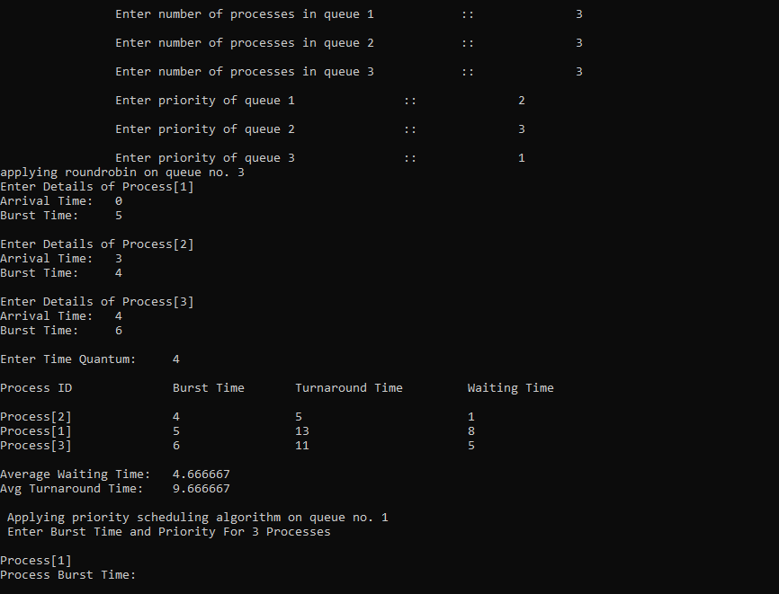
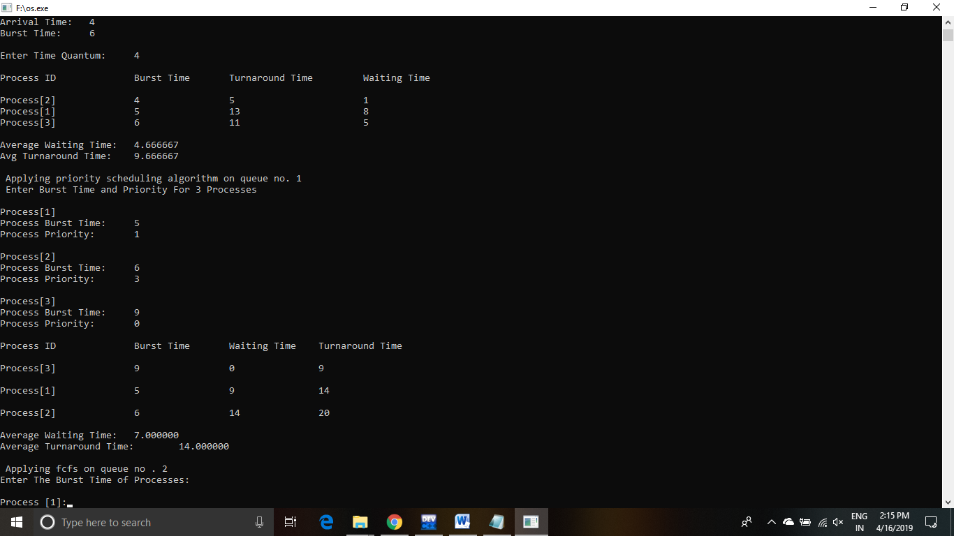
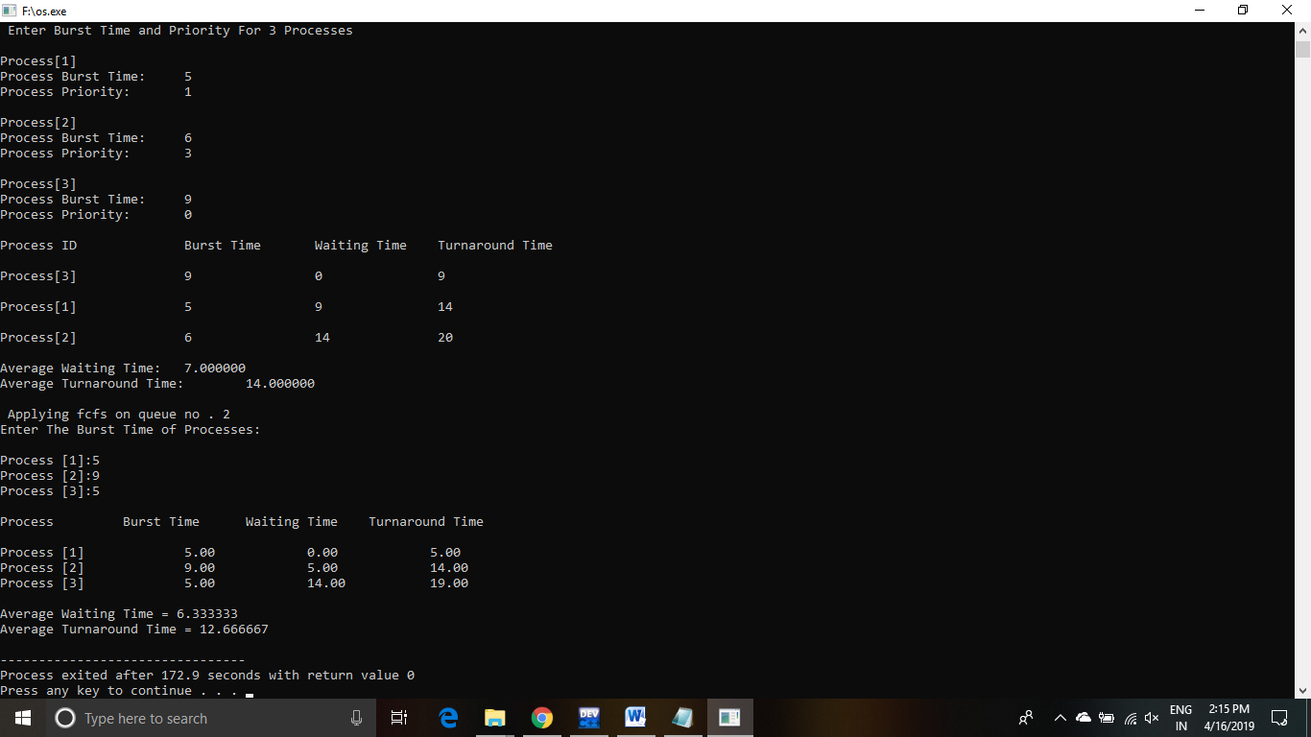

QUESTION. 2
Shortest Job First

Programming Code:

#include<stdio.h>
#include<unistd.h>
#include<stdlib.h>
int n;
struct process
{

int p_no;

int arrival_t,burst_t,ct,wait_t,taround_time,p;

int flag;
}p_list[100];
void Sorting()
{
struct process p;

int i, j;

for(i=0;i<n-1;i++)

{

for(j=i+1;j<n;j++)

{

if(p_list[i].arrival_t > p_list[j].arrival_t)

{

p = p_list[i];

p_list[i] = p_list[j];

p_list[j] = p;

}

}

}
}
int main()
{
printf("\n ************************* SHORTEST JOB SCHEDULING ALLGORITHM PROJECT ***********************************");
printf("\t\t\tQ.15: A uniprocessor system has n number of CPU intensive processes, each process has its own requirement of CPU burst.\n\t\t\t\tThe process with lowest CPU burst is given the highest priority. A late-arriving higher priority process can\n\t\t\t\tpreempt a currently running process with lower priority. Simulate a scheduler that is scheduling the processes\n\t\t\t\tin such a way that higher priority process is never starved due to the execution of lower priority process.\n\t\t\t\tWhat should be its average waiting time and average turnaround time if no two processes are arriving at same time. \n\n");
system("pause");
system("cls");

int i,t=0,b_t=0,peak;

int a[10];

float wait_time = 0, taround_time = 0, avg_w_t=0, avg_taround_time=0;

printf("enter the no. of processes: ");

scanf("%d",&n);

for(i = 0; i < n; i++)

{

p_list[i].p_no = i+1;

printf("\nEnter Details For P%d process:-\n", p_list[i].p_no);
printf("Enter Arrival Time: ");
scanf("%d", &p_list[i].arrival_t );
printf("Enter Burst Time: ");
scanf("%d", &p_list[i].burst_t);
p_list[i].flag = 0;
b_t = b_t + p_list[i].burst_t;
}
Sorting();
for(int i=0;i<n;i++)
{
a[i]=p_list[i].burst_t;
}
p_list[9].burst_t = 9999;
for(t = p_list[0].arrival_t; t <= b_t+1;)
{
peak = 9;
for(i=0;i<n;i++)
{
if(p_list[i].arrival_t <= t && p_list[i].burst_t < p_list[peak].burst_t && p_list[i].flag != 1)
{
peak = i;
}
if(p_list[peak].burst_t==0 && p_list[i].flag != 1)
{
p_list[i].flag = 1;
p_list[peak].ct=t;p_list[peak].burst_t=9999;
printf("P%d completes in %d\n",p_list[i].p_no,p_list[peak].ct);
}
}
t++;
(p_list[peak].burst_t)--;
}
for(i=0;i<n;i++)
{
p_list[i].taround_time=(p_list[i].ct)-(p_list[i].arrival_t);
avg_taround_time=avg_taround_time+p_list[i].taround_time;
p_list[i].wait_t=((p_list[i].taround_time)-a[i]);
avg_w_t=avg_w_t+p_list[i].wait_t;
}
printf("PNO\tAT\tCT\tTA\tWTt\n");
for(i=0;i<n;i++)
{
printf("P%d\t%d\t%d\t%d\t%d\n",p_list[i].p_no,p_list[i].arrival_t,p_list[i].ct,p_list[i].taround_time
,p_list[i].wait_t);
}
printf("Average Turn around Time: %f\t\n\n",avg_taround_time/n);
printf("Average Waiting Time :\t %f\t\n",avg_w_t/n);
}

OUTPUT of PROGRAM:
